**Advance Excel Assignment 4**

1. To use the ribbon commands, what menu and grouping of commands will you find the Insert and Delete command?

Ans. Microsoft Excel ribbon is the row of tabs and icons at the top of the Excel window that allows you to quickly find, understand and use commands for completing a certain task.

Ribbon tabs

The standard Excel ribbon contains the following tabs, from left to right:

**File** – allows you to jump into the backstage view that contains the essential file-related commands and Excel options. This tab was introduced in Excel 2010 as the replacement for the Office button in Excel 2007 and the File menu in earlier versions.

**Home** – contains the most frequently used commands such as copying and pasting, sorting and filtering, formatting, etc.

**Insert** – is used for adding different objects in a worksheet such as images, charts, PivotTables, hyperlinks, special symbols, equations, headers and footers.

**Draw** – depending on the device type you're using, it lets you draw with a digital pen, mouse, or finger. This tab is available in Excel 2013 and later, but like the developer it is not visible by default.

**Page Layout** – provides tools to manage the worksheet appearance, both onscreen and printed. These tools control theme settings, gridlines, page margins, object aligning, and print area.

**Formulas** – contains tools for inserting functions, defining names and controlling the calculation options.

**Data** – holds the commands for managing the worksheet data as well as connecting to external data.

**Review** – allows you to check spelling, track changes, add comments and notes, protect worksheets and workbooks.

**View** – provides commands for switching between worksheet views, freezing panes, viewing and arranging multiple windows.

**Help** – only appears in Excel 2019 and Office 365. This tab provides quick access to the Help Task Pane and allows you to contact Microsoft support, send feedback, suggest a feature, and get quick access to training videos.

**Developer** – provides access to advanced features such as VBA macros, ActiveX and Form controls and XML commands. This tab is hidden by default and you have to enable it first.

**Add-ins** – appears only when you open an older workbook or load an add-in that customizes the toolbars or menu.

1. If you set a row height or column width to 0 (zero), what happens to the row and column?

Ans. It sets to the default width or height.

1. Is there a need to change the height and width in a cell? Why?

Ans. It is necessary to change width and height in excel to fit the data. Excel by default provide equal width and height with respect to columns and rows. Whenever we enter a lengthy data, few characters will get displayed and other will be present inside the cell but will be hidden to the user. It is necessary to change the rows and column’s height and width to have a good presentation in excel. Few other cells width and height needs to be reduced so that it represents a smaller amount of data such as Gender which accepts ‘F’ or ‘M’.

1. What is the keyboard shortcut to unhide rows?

Ans. **Ctrl+Shift+9** is the keyboard shortcut to unhide rows.

1. How to hide rows containing blank cells?

Ans. To hide rows that contain any blank cells, proceed with these steps:

* Select the range that contains empty cells you want to hide.
* On the Home tab, in the Editing group, click Find & Select > Go To Special.
* In the “Go To Special” dialog box, select the Blanks radio button, and click OK. This will select all empty cells in the range.
* Press ctrl+9 to hide the corresponding rows.

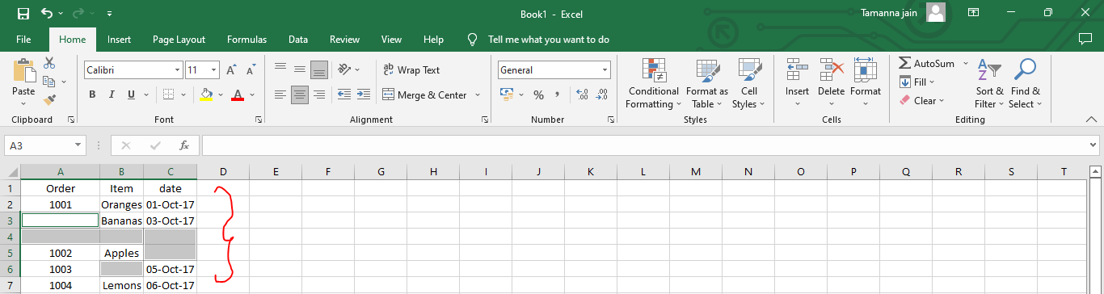

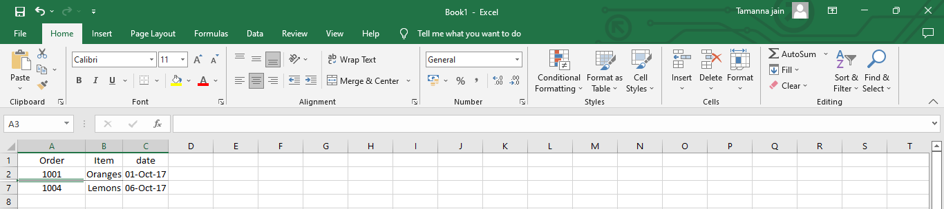

1. What are the steps to hide the duplicate values using conditional formatting in excel?

Ans. Steps are as follows :

* + Select the range you want to hide duplicates.
  + Then click **Conditional Formatting** > **Highlight Cells Rules** > **Duplicate Values** under **Home**tab.
  + In the **Duplicate Values** dialog box, select**Custom Format** in the v**alues with** drop-down list, and then click the **OK** button.
  + In the **Format Cells** dialog box, go to the **Font** tab, and in the **Color** drop-down list, choose a font color which matches the background color of your selected range cell. And finally click the **OK** button.
  + When it returns to the Duplicate Values dialog box, click the OK button.

Now all duplicate records in selected columns are hidden immediately.